Day 25: 18-11-2025:

Message system or Messaging Service
Messaging service is a type of service to transfer the messages from one application to another application. Generally we achieve message service concept using MOM. Message Oriented Middleware
“Every DAD required MOM”
Distributed application developer required Message Oriented middleware.
Limitaiton of Web Service or Rest API or Micro Service Rest API. Both application must be type of web application.
Both application must be running at that point of time. Means consumer as well as producer must be running. If producer running consume the data.

Client Server

MOM
We do 2 types of messaging
- P2P - Point 2 Point communication : one client to another client
Queue Queue is a type of container which hold message for temporary purpose

- Pub/Sub - Publisher and Subscriber Airtel - we are subscriber.
Topic it is type of container which hold publisher message.
Topics doesn’t.

Message can be any types
Byte, char, stream, object, json format. Etc.

MOM implementation
JMS : Java Messaging service : technology
MQ : message queue : IBM
Active MQ : open source
Rabit MQ
Sonic MQ

Apache Kafka
Apache Kafka is an open source software or tools developed by Apache organization. Apache Kafka written using Java and Scala. Apache Kafka mainly use to distributed messages using pub/sub (with topics). concept. In Apache Kafka data is very huge. Apache Kafka internally use stream concept to share the data between on application to another application. These data share in asynchronous manner.
MOM -

In Apache Kafka broker,
Consumer and producer application can be console base, web application, mobile application, and can be any technology like Java, python, C#, C, C++, Scala etc.

One technologies they publish the data of any types.
More than one application running using different technologies they can consume that data.

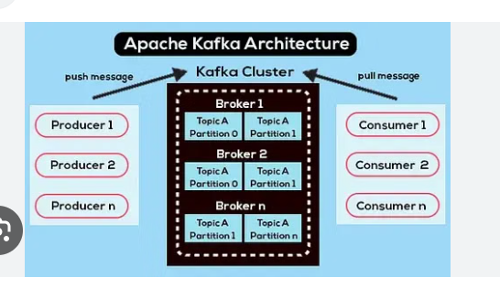

Download Apache Kafka

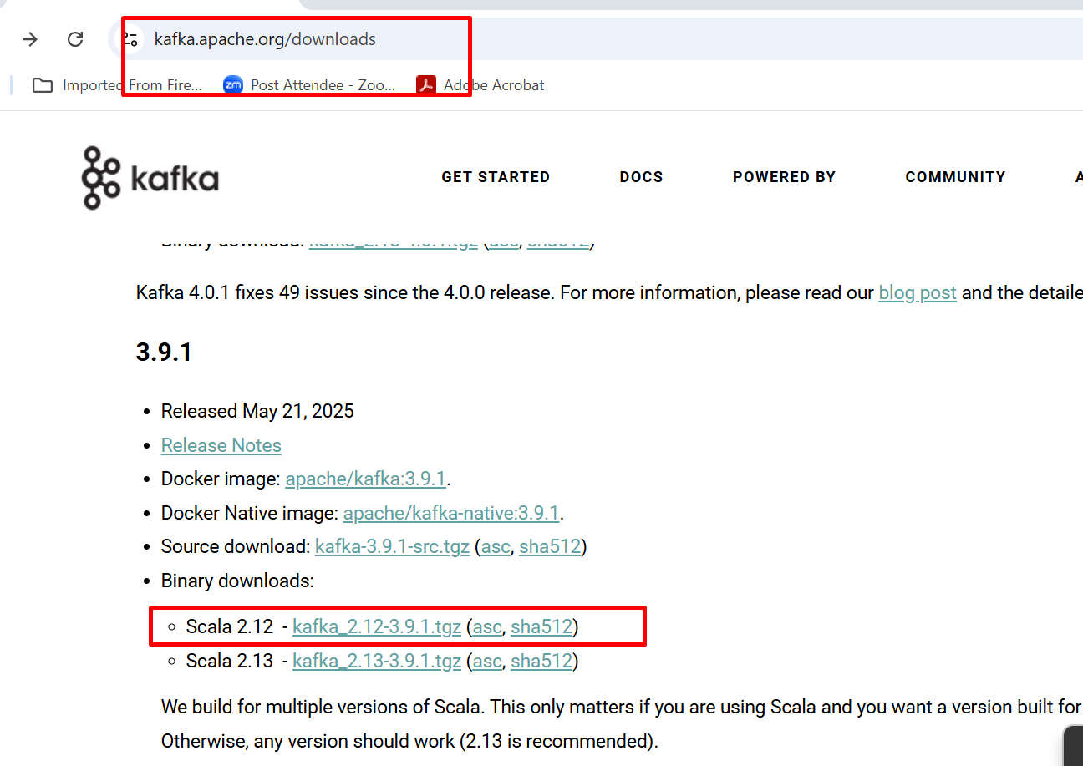

After downloaded the software. Please extract the folder and keep in C or D drive.

To start the ZooKeeper. Open the command prompt inside a kafka bin - window folder

Below command help to start the Zookeeper
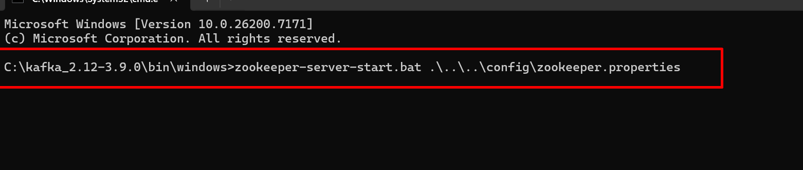

Zookeeper run on port number 2181

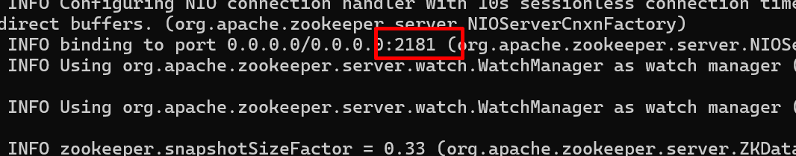

Now we need to start Apache Kafka Service

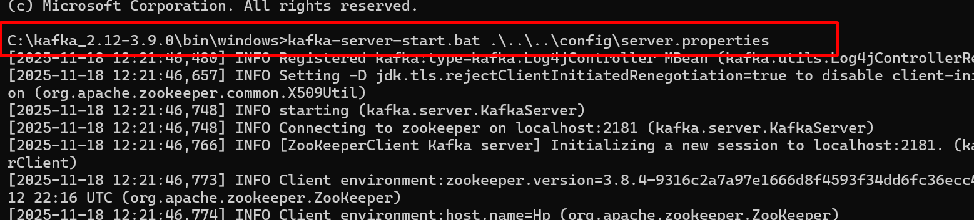

Apache Kafka Broker
- Apache Kafka broker is a single server instance. Which is responsible for store the message. Inside an Apache software we can create more than one broker. Each broker can create more than one topic. Topic is use to hold the message.
Zookeeper : Zookeeper is a distributed coordinate service use by different MOM product like Apache Kafka, Hadoop, Hbase etc.
Zookeeper is responsible to hold details about the broker. It is use hold the meta data about the broker and topics, message partition etc.

First we need to start the Zookeeper

Open the command prompt in admin account.

Open the command prompt in Apache Kafka software inside path as
Kafka x version bin Window

